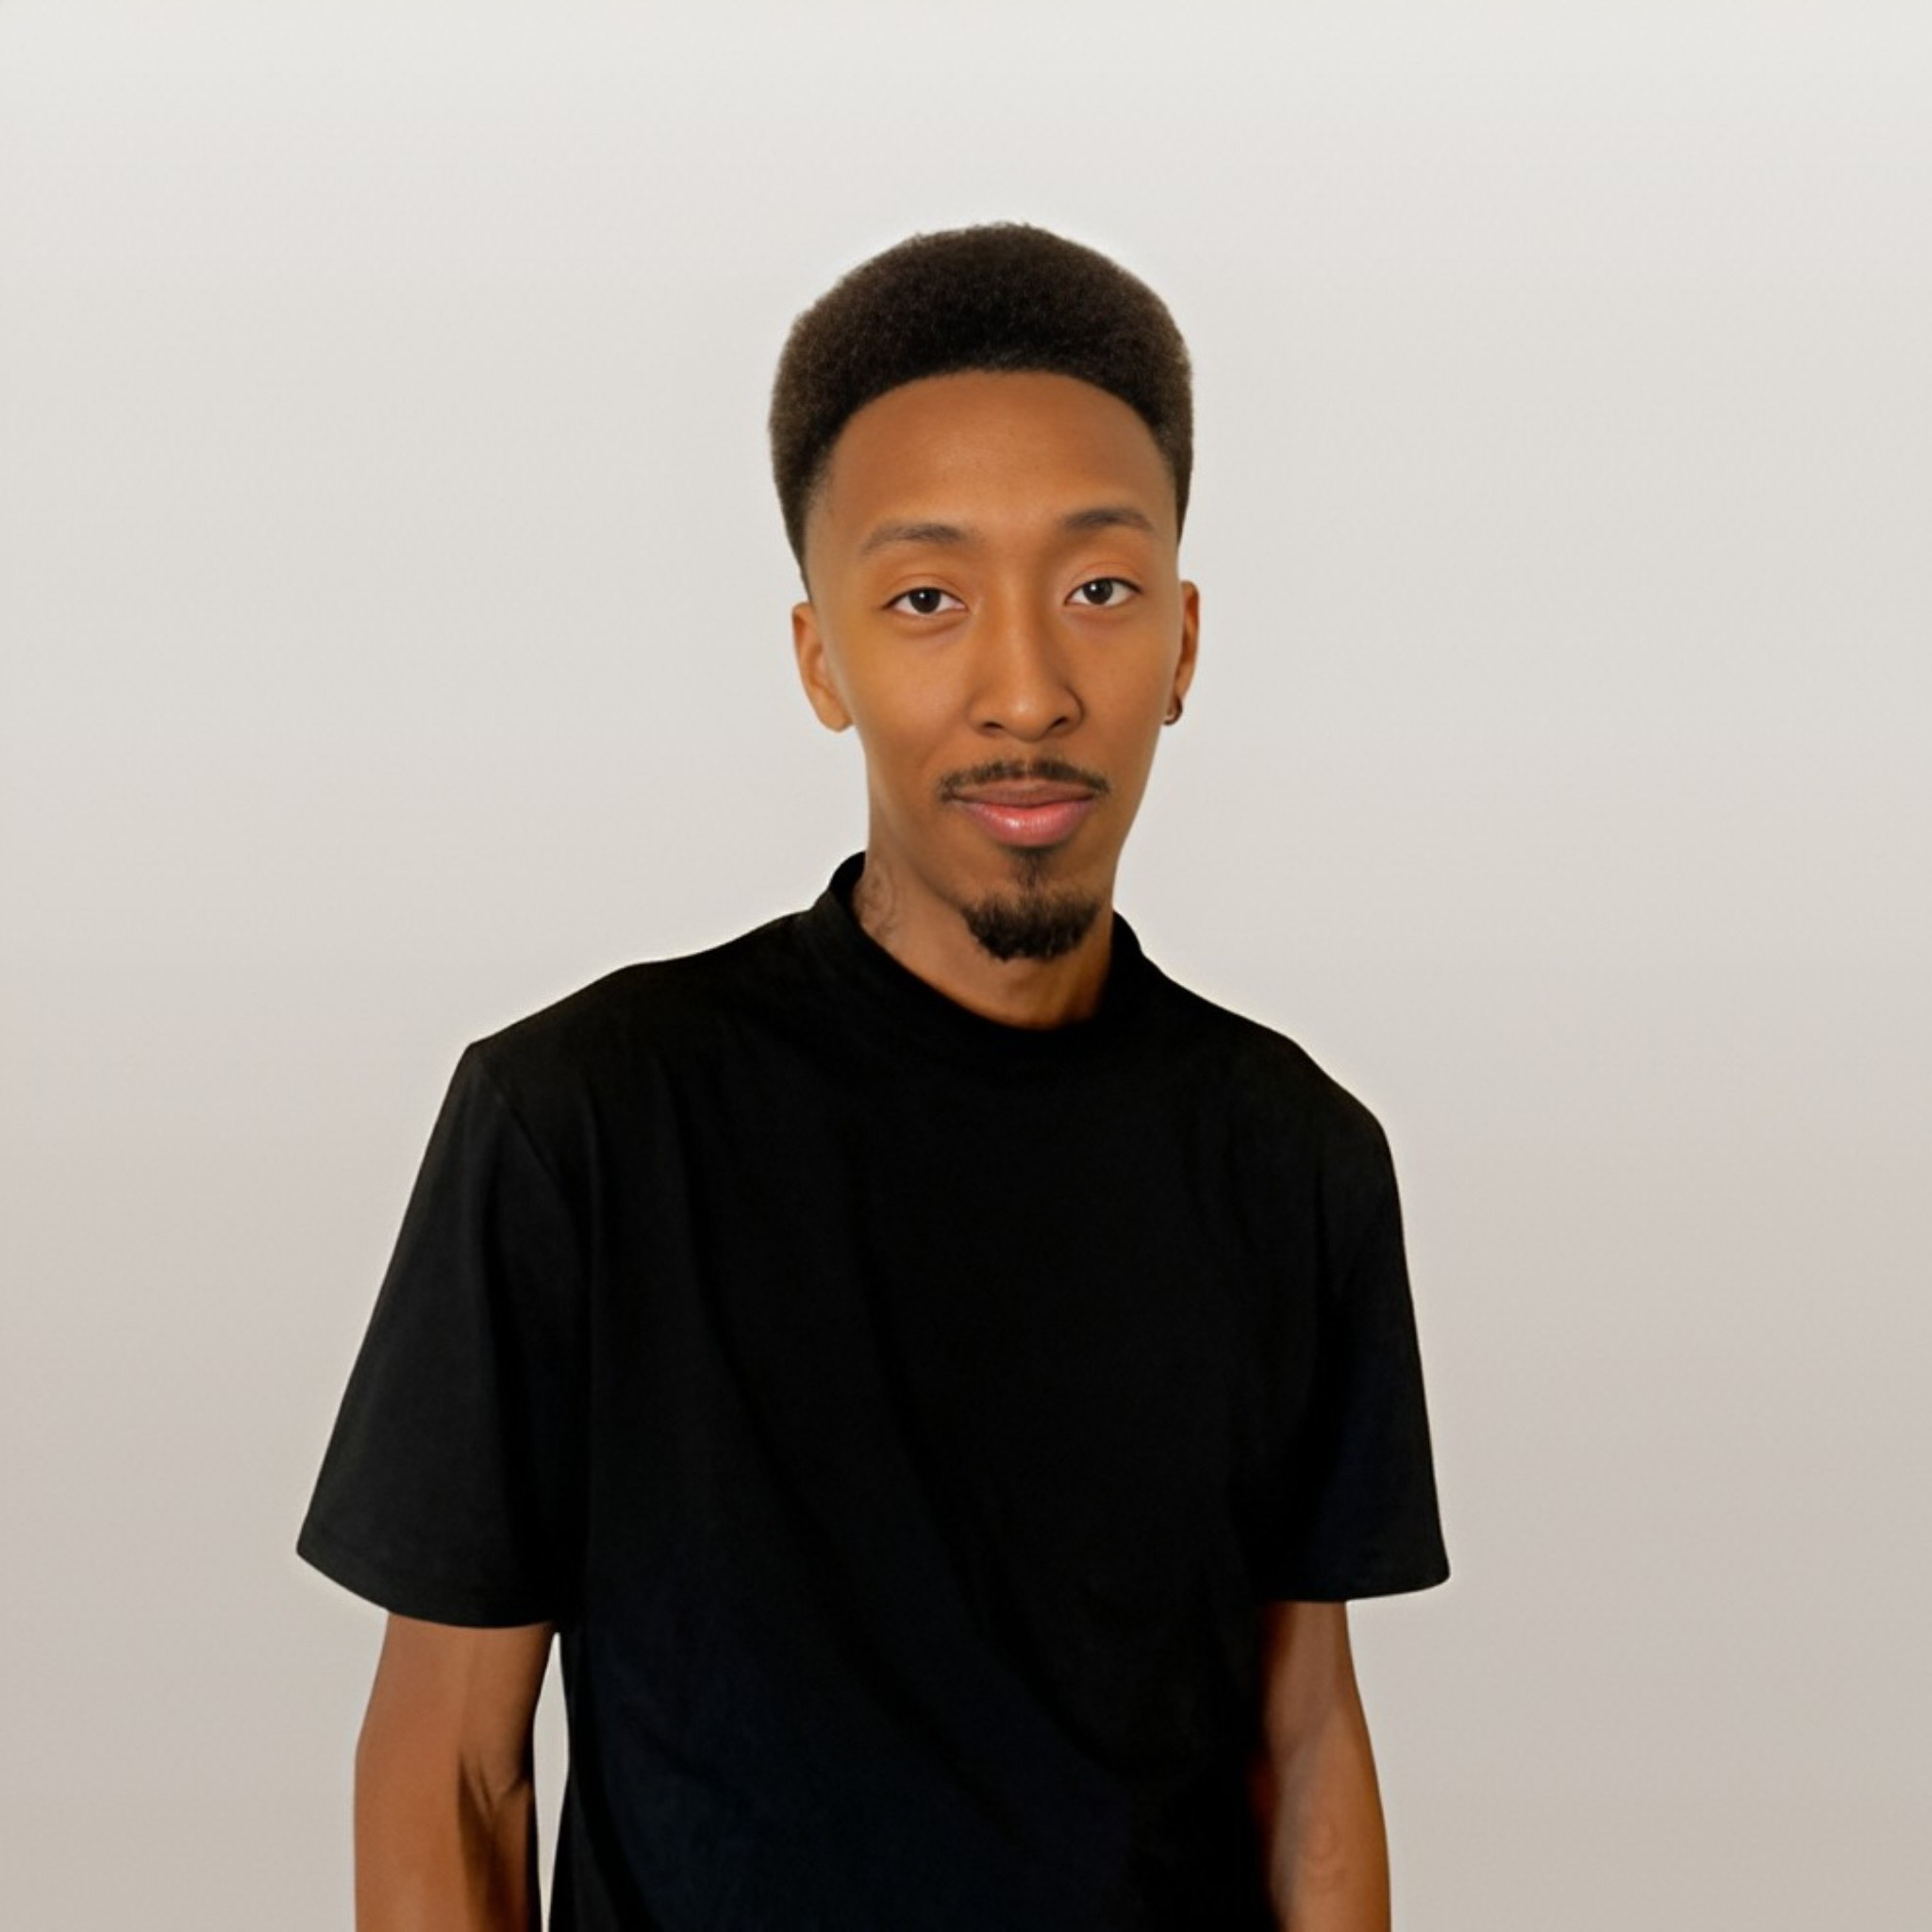
Enrique Penn
480-849-6248
Ricopenn6@gmail.com

Actor/Model

Height: 5’11
Age: 29
Weight: 140lbs
Hair: Brown
Eyes: Brown

PERFORMANCE
Arizona’s Got Talent 2015 Finalist

MCCCD Competition 2016 Choreographer/Dancer
Phoenix Suns Halftime 2016 Be Kind Crew

THEATER
The Glass Menagerie 2016 Dancer

FILM/SHORT FILM
Short film Comp HS 2014 Actor/Director
1234|5678 Short film 2017 Actor
Rhythm & Flow Ep.7 2019 Dancer
No Signal 2025 Actor/Director
Impatient 2025 Actor/Director
The Rendezvous Vendetta 2025 Actor/Stuntman

EDUCATION
GLENDALE COMMUNITY COLLEGE
FILM/DANCE:
Studies include: Acting, Voice/ Speech, Dance (Contemporary, Jazz, Hip-Hop), Camera Acting, Camera editing.

INDEPENDENCE HIGH SCHOOL
High School Diploma, June 2014

SPECIAL SKILLS
Tumbling, Improvisation, Sports (Basketball, Baseball,), Dance, Communication, Tech Savvy, Reading, Film editor,

